*Florida International University*

*School of Computing and Information Sciences*

Software Engineering Focus

Feature Document

User Story ID <NVOS-32 View Click History>

**Name:** Bryan Bastida

**Team Member(s):** Bryan Bastida

Andrew Castillo

**Project:** Envo Scholar

**Product Owner(s)**: Mark Finlayson

**Mentor(s)**: Masoud Sadjadi

**Instructor**: Masoud Sadjadi

**User Story Name:**

Description: As a user, I want to view the articles I have clicked on, to be able to get to them faster if I never saved them.

Acceptance Criteria

* User is logged in
* User has clicked on the Click History button

**Use Case**

* Name: View Click History
* Actor: User, Webpage, User Server, MongoDB
* Preconditions: User is logged in

User has searched for an article

User has clicked on an article

User clicked on the Account button

User clicked on the Click History button

* Description <Flow of events>: User clicks on the Account button

User logs into their account

User searches for an article

User clicks on the article

User goes to their profile

User clicks on the Click History button

Website routes to the Click History page displaying the

article informaiton of the article the user has clicks on.

**Use Case Diagram**

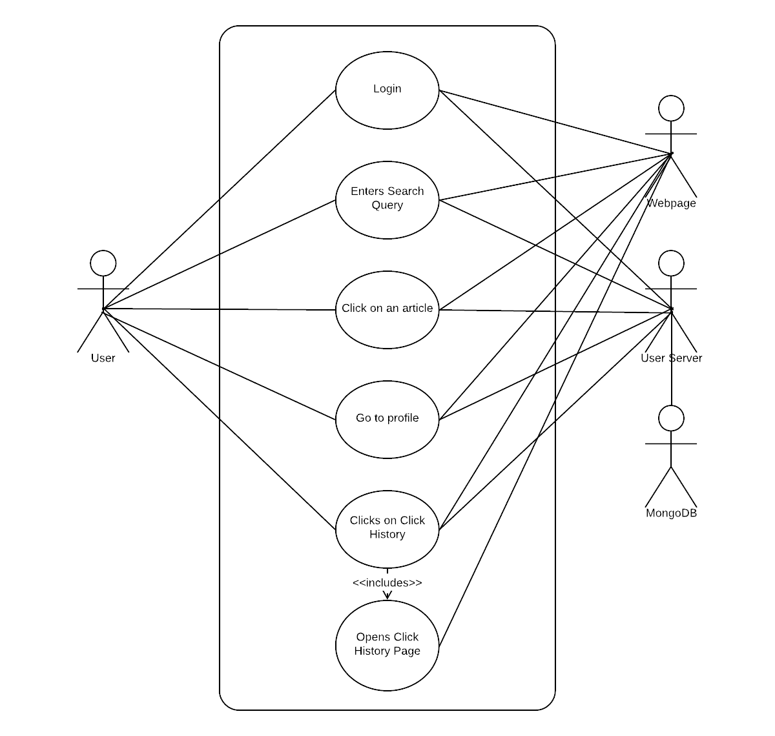

**Sequence Diagram**

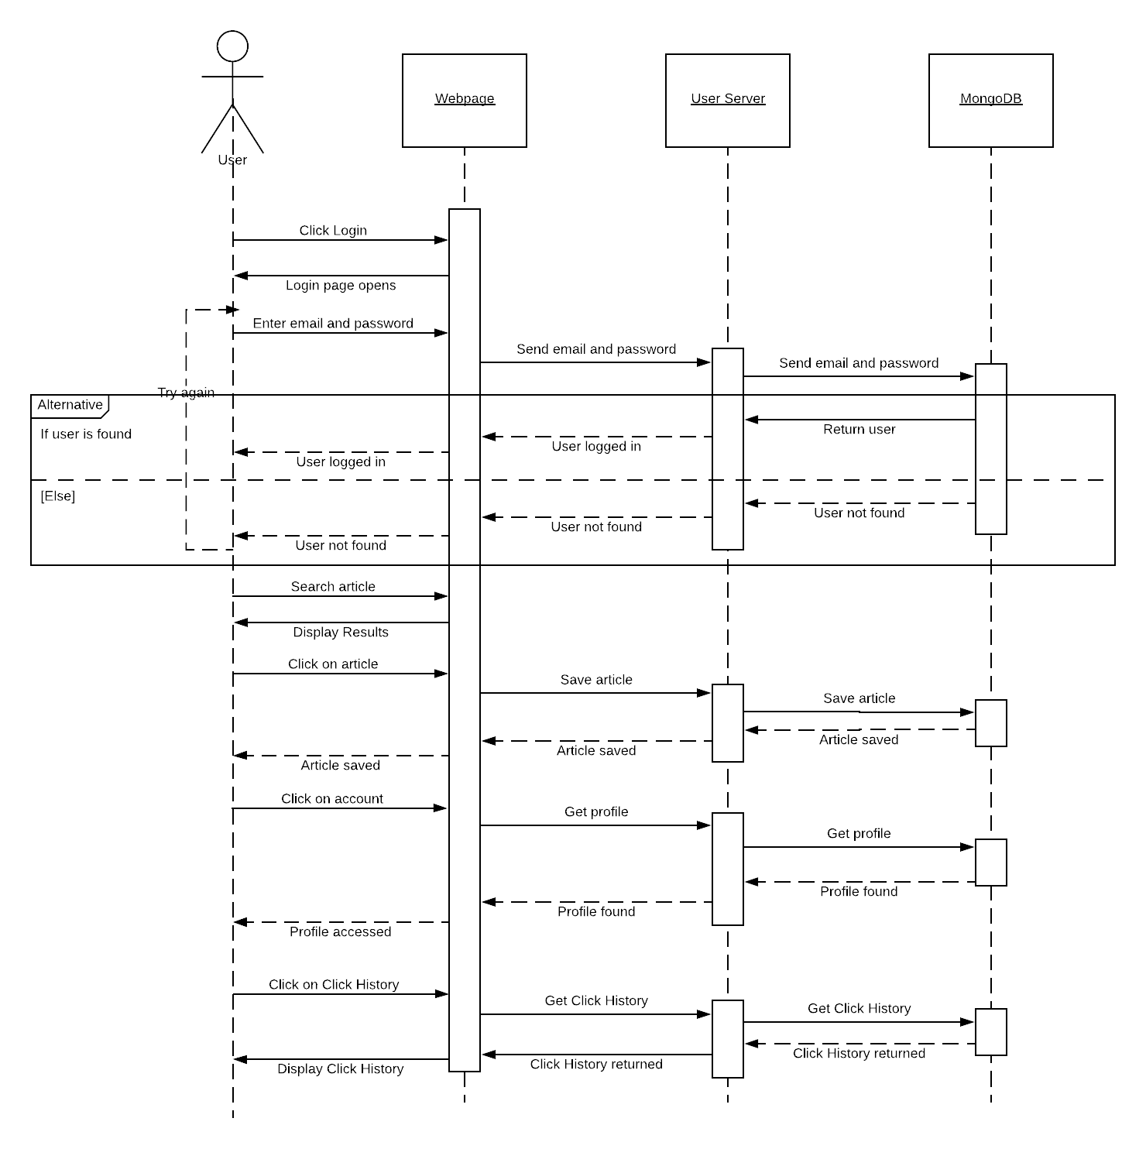

**Class Diagram**

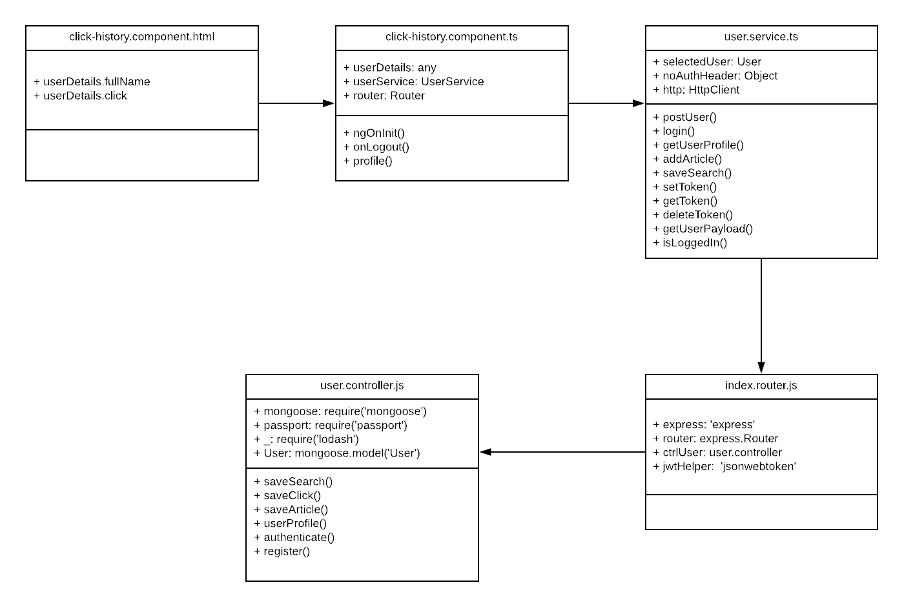

**Unit Test**

* Test case ID: NVOS-32-View-Click-History
* Description/Summary of Test: This test was made to check that a user is able to view their click history
* Pre-condition: User is logged into their account

User has searched for an article

User has clicked on the article

User goes to their profile page

User clicks on Click History

* Expected Results: Click history is displayed
* Actual Result: Click history is displayed
* Status (Fail/Pass): Pass

**Visual User Guide**

